Brendan Clarke
CS 499
Enhancement 2 Narrative

For my CS 330 class I had developed an OpenGL rendered environment with special shapes to make up for a real photo that I took. This class gave me a lot of freedom, so in those ways I had created a scene like one I had encountered in real life. Two weeks prior to this class starting my first child was born, so now in my Livingroom had sat a bassinet for the little one. I got to see Arthur fall asleep in this little basinet to my reprieve as I then followed sleeping next to him on the floor so I can wake up easily if he does.
This room was very simple, the backdrop walls, and textures were basic pixel art graphics I edited together to best match my real-life living room. While I am no artist, this gives a reasonable representation of what it was to me, with basic colors and outlines of each of the objects I chose to include. While OpenGL in combination with C++ isn’t inherently slow to render, for a beginner like me it certainly can be. I do have a decent computer, so I never quite ran into true frame rate issues, this is most likely due to the lack of animation or complex processing. However, in any sense the scale of design could easily be implemented with the same logical foundation as my simple environment here.
This project got me thinking about polygons! The star shape originally was using a simple math equation to find its next side, and the same for the bassinet walls and frame. So now that I am returning to enhance this work, I wanted to focus on making my scene render more efficiently.
What specific components of the artifact showcase my skills and abilities in algorithms and data structure? This project allowed me to show my deep understanding of memory management (thanks rust), data structure selection and algorithmic complexity. In my enhancement, I defined a struct shape to encapsulate the rendering properties of an object, this shows my ability to organize complex data into logical and reusable ways.
I then used the C++ STL to help me create a dynamic scene graph. By storing “Shape” objects in vector, I could ensured that there was adjoining memory allocation. This shows my ability to best utilize spatial locality. This made it so the CPU uses minimal cache compared to scattered heap allocation. This greatly improves the data retrieval during rendering.
Finally, I refactored the rendering logic from a linear sequence of manual calls to functions to a generalized iterative algorithm. This new render loop processes the sceneGraph vector, applies the transformations and then draws calls through a dynamic procedure. This will break down the data from the rendering allowing the algorithm to then handle N objects without requiring any changes to the code structure (Thank got I was worried about this part needing major changes to how the original project was framed.)
I did also integrate an FPS (frames per second) counter and a frame time to the window title bar. This help me understand where my processing was prior and where it went to. (this partially was to also test if my new and improved rendering flow didn’t create unwanted bottlenecks as a drop in frame rate is one thing, but a change in the ms between frames could be indicative of something structurally causing problems with one part of my pcs hardware.)
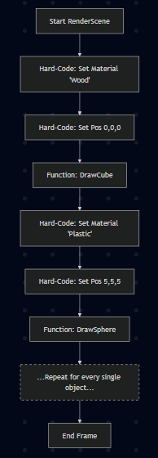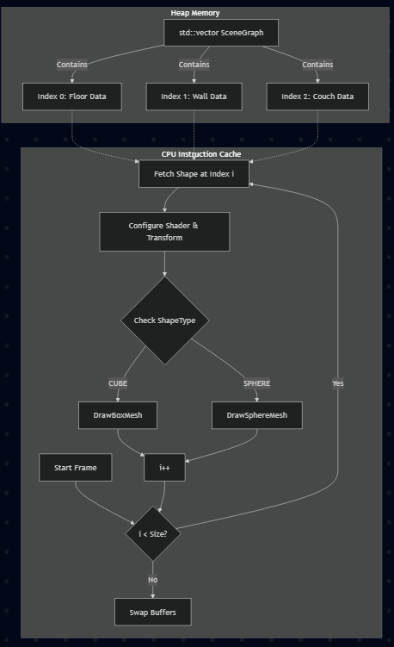
Above show on the left the initial approach which was linear and required way more hardware usage due to the amount of objects I had created in the scene. The right shows the new and improved rendering procedure which is data first. This new procedure is more intuitive for computers to run and ensure it uses as little memory and cpu power as possible.

There were some minor difficulties in getting my code to run again, I had run into build errors for missing files. I ultimately found a way to open my original project and not just download the github repo and open the .sln as even with my correction of the libraries file path it did not resolve the .h files and library files not being found. After opening the original project, I had to modify the code to match the final state of my assignment when it was submitted.
After correcting the rendering process, I had to ensure that this new code was improving my hardware usage. I compared it to my earlier version and saw that my new code helped for a 3% cpu usage drop. This number can be differing on your specific hardware, and however many objects are included in the scene.
This process for developing a solution for a problem I couldn’t think of several months ago was based on my development since last July, and my ability to think of what designing software is about. We can do anything with software engineering, but we cannot make hardware faster than it is. We can find new ways to improve our codes performance, (take notes Microsoft.) as the faster your code can run on one machine the more people who maybe have a lack of faster hardware can now use your software. That means more people whose lives you just made a little more interesting and depending on what your code actually does maybe you have now helped more people than you originally could.

